Tab 1
PhishLens AI
An Explainable AI-Based System for Detecting Phishing Attempts in WhatsApp Images.

Your system will detect phishing or scam attempts from screenshots / forwarded images received on WhatsApp.
- Example image types:
- Fake bank alert screenshots
- Fake UPI payment proof
- Fake job offer posters
- Fake KYC warning images
- Fake giveaway / lottery banners
- Fake account suspension notices
- QR scam posters
- Fake customer care contact images

CORE IDEA
User uploads or shares a WhatsApp image → Your system analyzes the image → Extracts text using OCR → Runs phishing/scam detection →

Shows:
- Risk score
- Phishing type
- Reasons why it is suspicious
- Safe action recommendation

HOW IT WILL WORK (ACTUAL PIPELINE)
Input: User uploads an image from WhatsApp
- Step 1 – OCR Extract text from the image
- Step 2 – Feature Detection: Look for scam indicators such as:
- urgency words (“urgent”, “immediately”, “account blocked”)
- money bait (“win ₹50,000”, “cashback”, “lottery”)
- fake authority (“SBI”, “PhonePe”, “Government”, “KYC”)
- suspicious numbers / links / QR references
- emotional manipulation
- Step 3 – AI / Rule Hybrid Detection
  - Classify image as:
- Safe
- Suspicious
- Highly Likely Phishing
- Step 4 – Explainability Layer
- Tell user:
- why it was flagged
- which words or cues triggered detection
- Step 5 – Safety Suggestion
  - Example:
    - Do not call this number
    - Do not scan this QR
    - Verify through official website
    - Do not share OTP

BEST PROTOTYPE YOU SHOULD BUILD
One Web App Prototype
- Easiest to demo
- Easiest to code
- Easiest to test
- Easiest for research paper
- Easiest for team collaboration

TECH STACK
Frontend  HTML / CSS / JS  or  React | Backend  Python + Flask  AI / OCR  Python  Tesseract OCR or EasyOCR  scikit-learn  Database (optional)  SQLite or Firebase (only if needed)
The current work is implemented as a prototype web application, with future scope for Android and WhatsApp integration.”

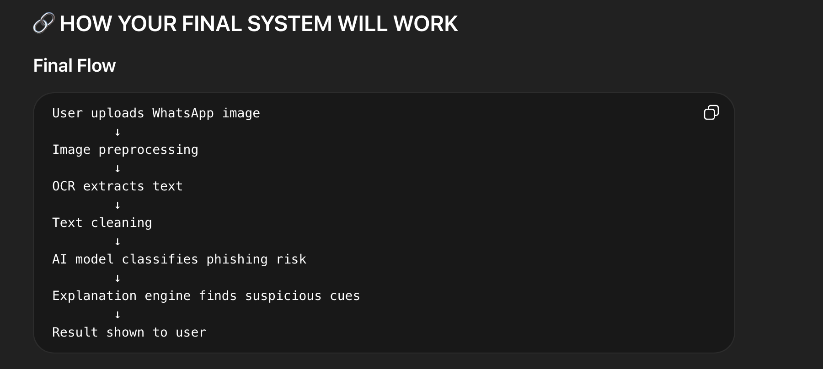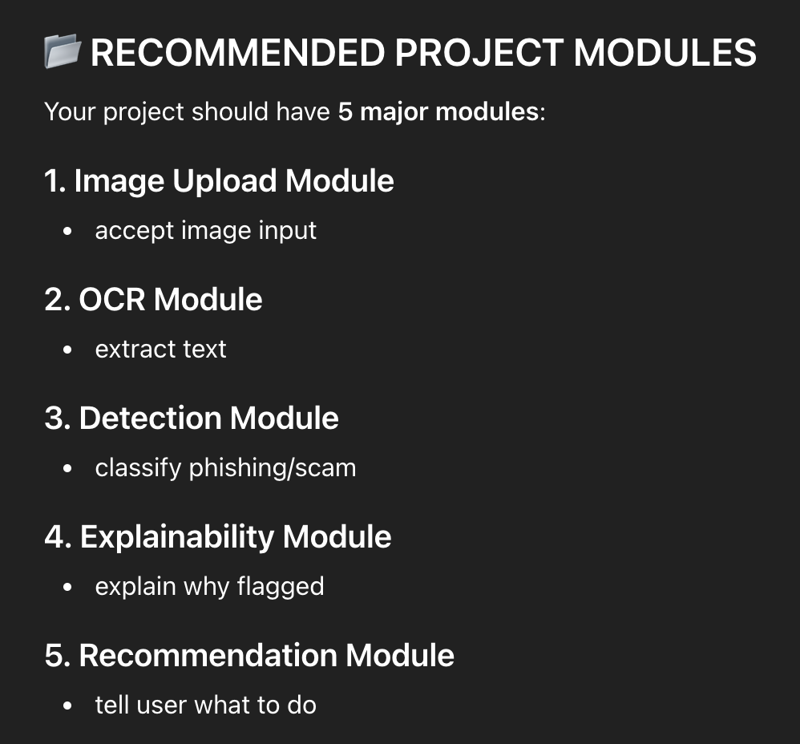

Report Division

📄 REPORT DIVISION (WHO WRITES WHAT)
This will save you a lot of time.

Durgesh
- Abstract
- System Architecture
- Innovation / Novelty
- Conclusion

Khushi
- Introduction
- Problem Statement
- Objectives
- Literature Review
- Applications
- Future Scope

Arnav
- Frontend Design
- UI/UX Section
- Screenshots

Rahul
- OCR Methodology
- Preprocessing
- Image pipeline

Yash
- Backend
- AI Model
- Algorithm
- Results / Evaluation

Research Paper Divison

📑 RESEARCH PAPER DIVISION

Durgesh
- title
- abstract
- proposed system
- novelty

Khushi
- introduction
- related work
- literature review

Rahul
- OCR + image pipeline methodology

Yash
- ML model + results

Arnav
- system implementation + user interface

